Thailand is more than just dazzling streets, exquisite Thai food, relaxing massages and god-awfully nice people. While the country is infamous for its roaring nightlife, marked by lively pubs, and party hostels, there’s more to the beautiful country than what you see on social media. This is just Bangkok we’re talking about. There’s so much more to the Asian nation than its capital city that invites hoards of travellers every year. I was one of them. I realised the true beauty of Thailand when I engaged in a conversation with my cab driver whose English was just good enough to be understood.

I had planned on visiting Bangkok and then flying back to India after four days, but this unexpected cab drive made my plan take a 180-degree turn as I booked a flight to Phuket and made my way to the Phi Phi Islands, from where I went to Krabi and a few other islands. This is what Thailand is all about, the picturesque d islands that offer not just ethereal beauty, but also a ton of fun water activities that will give you the best thrill of life. This article covers the 4 best islands to visit while you’re in the majestic Asian country. Let’s make your next Thailand trip Bangkok-free.

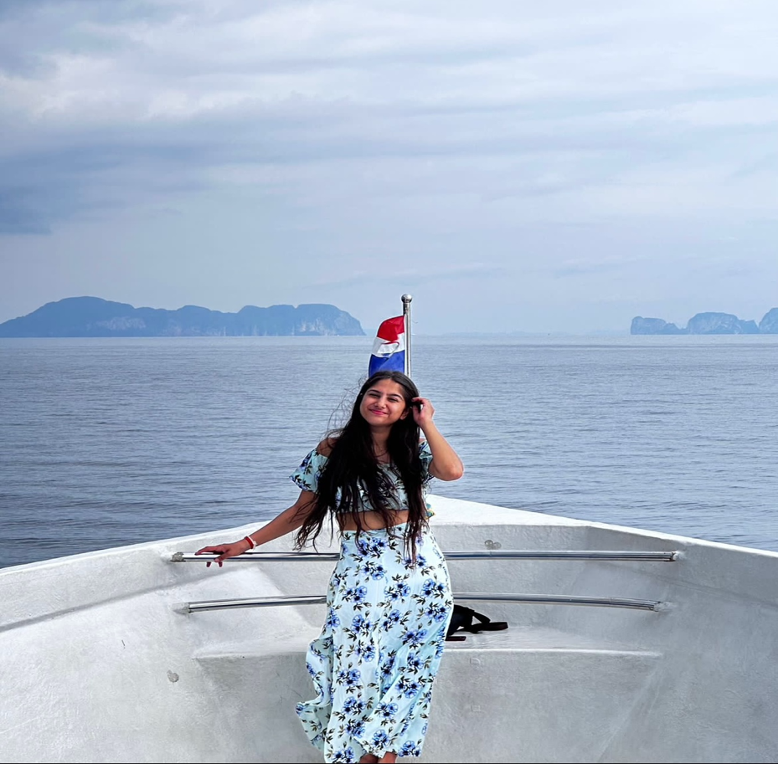

1. Phuket:

After Bangkok, Phuket is the most popular tourist city in Thailand. Standing in sharp contrast to the bustling capital city, Phuket is all about beautiful turquoise waters, white pristine sand, lively beaches, and close proximity to the best Islands in Thailand. Once you land in Phuket, you can take ferries to all the popular islands, locally known as “Koh”, including Koh Phi Phi, Koh Samui and Koh Krabi. Once you land in Phuket, you can make your way to the mesmerising oceans of the country and soak in the salt-suffused air. If you’re a party person, you’d find the best beach parties in this area. Just make your way to any prominent beach after sundown and you’ll have the time of yourself partying with like-minded people! If not, you can always book a party hostel and live like there’s no tomorrow.

1. Koh Samui:

Koh Samui is a quieter island known for its pristine beaches, majestic waterfalls, spectacular views, and wellness spas. This is where you come to rejuvenate your minds and soul. You can also take a thrilling dip into the oceans by signing up for exciting water sports such as deep sea diving, scuba diving, snorkelling or sea walking. You could also sail up high and soak in the enchanting views of the Island from a bird’s POV by signing up for parasailing. How cool is that? Koh Samui is also home to some of the most grand and ornate temples. If you want to have an immersive cultural experience, visit these historic temples and familiarise yourself with the rich heritage of the Thai

people

1. Phi Phi Island:

Unofficially, Phi Phi is famous for being the shooting location of Leonardo DiCaprio’s “The Beach”. But there’s more to this place than being just a Hollywood prop. Phi Phi is where life happens. This is where people of different countries, races, religions, cultures and languages come together to play beer pong and dance to the beats of Avicii’s “The Nights”. It’s also known for its rich marine life and stunning vibrant corals. Whether you’re a party person or someone who enjoys blue waters, colourful underwater life, and sandy feet, this is the place for you!

1. Ko Pha Ngan:

Ko Pha Ngan is where the party animals huddle and color the night with music and paints! Yes, you got it right. Here’s where you can experience the famous full moon party. The full moon party takes place at the beachside and goes the whole night. This is where you would find paint-covered bodies, with booze in their hands, and hearts that are carefree, dancing to the beats of the EDMs that are played the entire night. If you love parties, music and beaches, well, welcome home.

Be it culture, rejuvenation, or nightlife, Thailand is where you can experience it all. The diversity of experiences that you would find here is unmatched. If you’re planning on going to Thailand this year, try adding places other than Bangkok to your list. Thank me later!