My Favourite Travel Destination

Written by Radhika Pansare

Rishikesh: City of Peace and Spirituality

My favourite holiday destination is Rishikesh, Uttarakhand. Why? Well, let me tell you. When I was in sixth grade, my uncle took me on a road trip to Uttarakhand. Rishikesh remained the most special spot to me of all the places we visited. And, after 12 years, I revisited Rishikesh with my mother. Rishikesh has grown tremendously as a city, yet its enchantment remains unchanged.

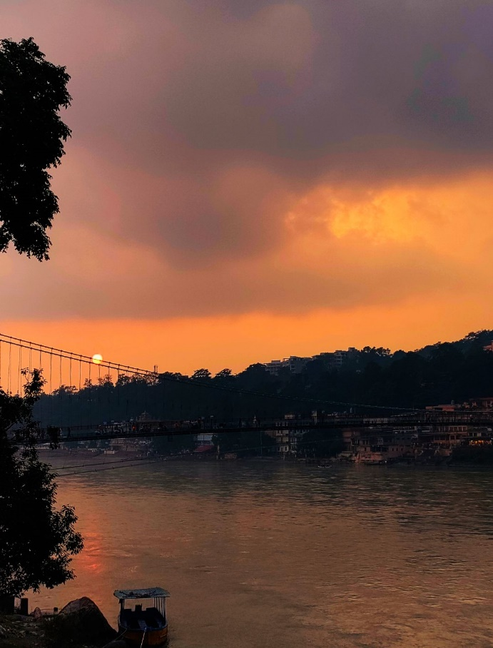

Along the banks of the Ganges River, Rishikesh sits on the foothills of the majestic Himalayas and has many aspects of being the cradle of Indian spirituality.

But you know what drew me to Rishikesh? The majestic Ganges. As I sat by the Ganges early in the morning, with a thin veil of mist covering me, listening to the sounds of gurgling waters, I felt a sense of liberation. When in Rishikesh, you must not miss the Ganga Aarti. Ganga Aarti has the capacity to unite millions of worshippers from all over the world in their quest for strength from the Ganges. We arrived to Parmarth Niketan Ashram at 6:15 p.m., since the pooja was scheduled to begin at 6:30 p.m., followed by the Aarti. When the aarti began, young boys stood on wooden tables with enormous lamps, synchronising their motions as the devoted audience broke into synchronised chanting and applauding. "Gange maa ki jai," screamed the singer, as thousands followed him. The music became louder when the bells rung. It was quite a sight. Despite the fact that the ghats were packed, I recall feeling reasonably quiet and at peace.

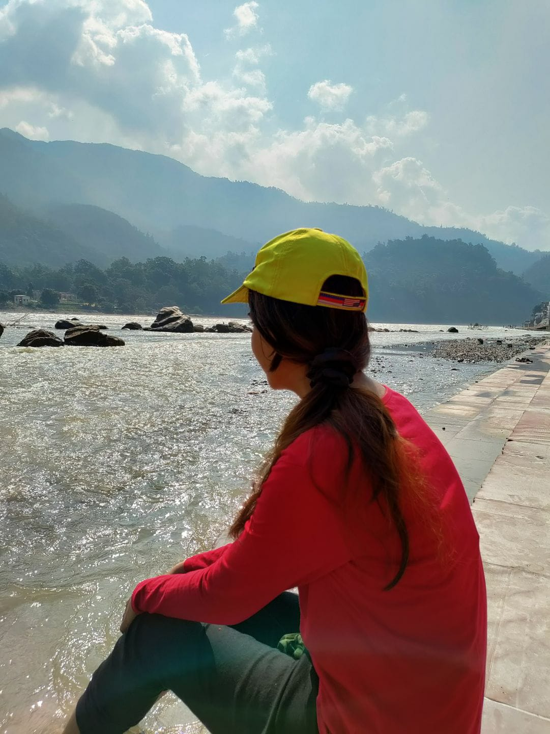

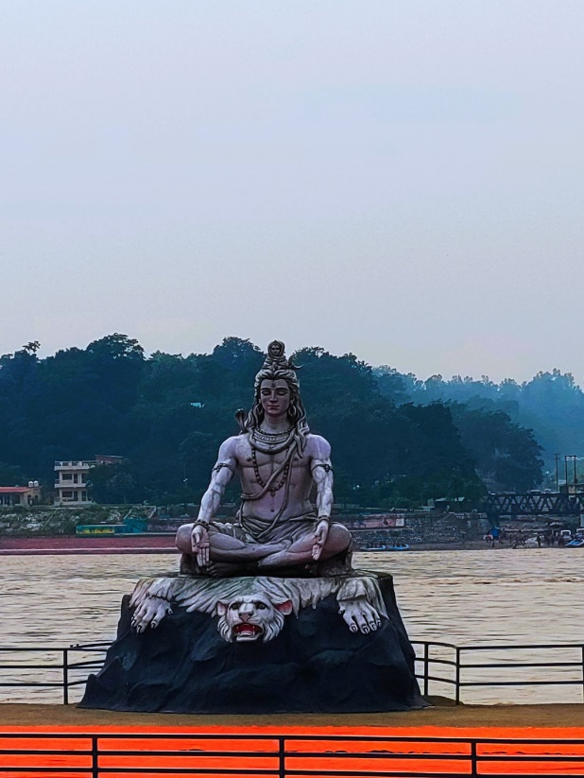Rishikesh is home to an array of ashrams which offer stay and food, as well as provide various types of spiritual programs and yoga sessions. During our stay in Rishikesh, we visited two Ashrams. The first was Parmarth Niketan, while the second was the well-known Beatles Ashram. Rather than hiring a vehicle, we preferred to walk to the Ashrams. During our walk to the ashrams, we encountered cows, tantra practitioners, crystal healers, street vendors, and countless tattoo shops.

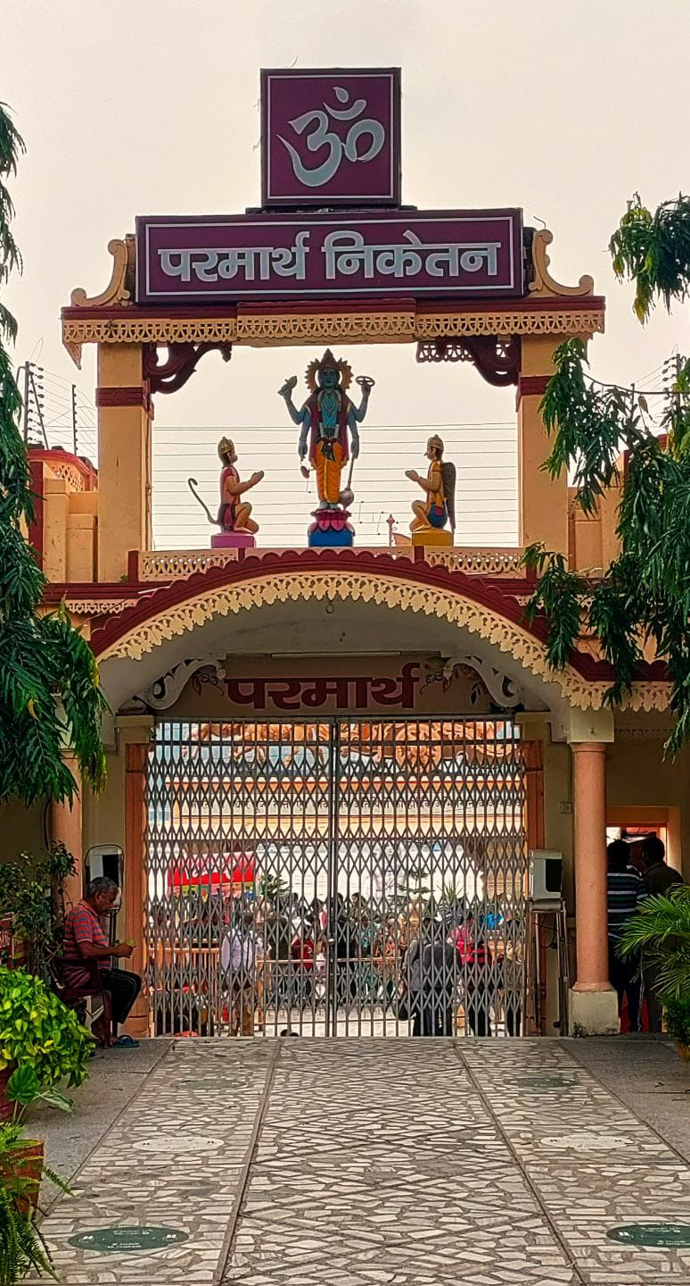

We spotted the enormous Parmarth Ashram as we strolled past the apparel stores. A statue of Lord Hanuman stood in front of it, one of the tallest statues in India. Rishikesh's Parmarth Niketan is one of the most beautiful and peaceful places. It is home to a sculpture of Shiva that is 14 feet tall and stands on a platform that is built over the flowing water.

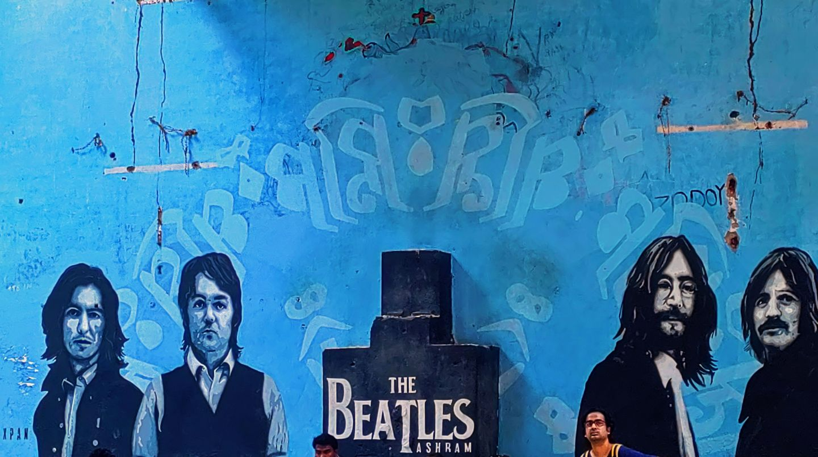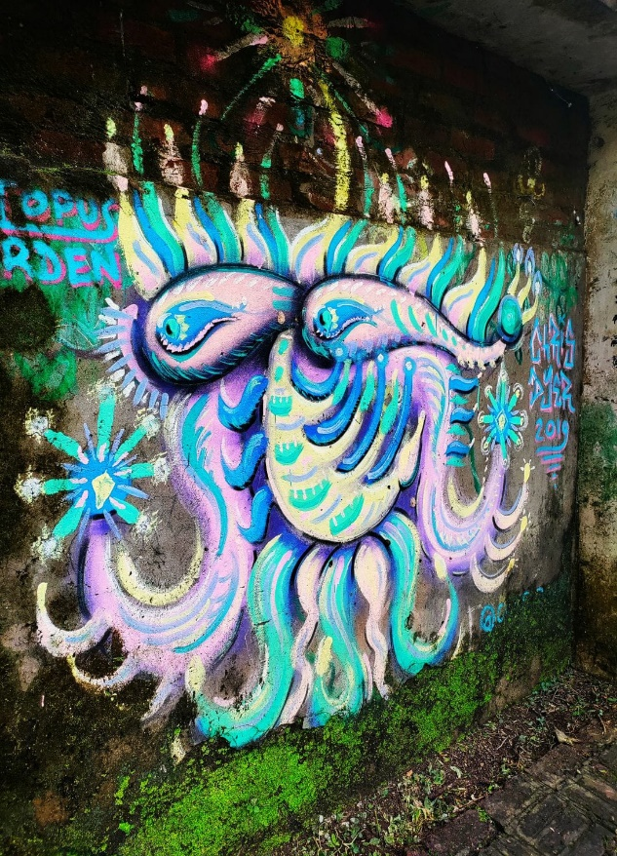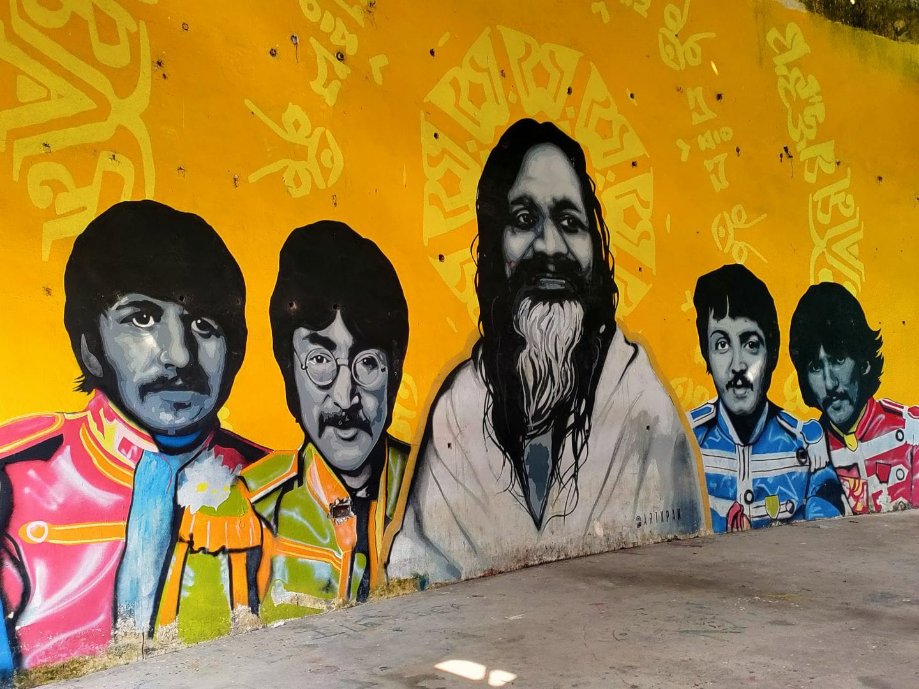

We then visited The Beatles Ashram after visiting Parmarth Niketan. The Beatles Ashram in Rishikesh is known as Chaurasi Kuti, which translates to "84 meditation huts." All of the huts are labelled with a number. It was amazing to see the small ashrams with rounded walls and a few of them also had small stairways leading up to the next level as soon as I entered one. Many have interesting graffiti on the walls, and the one I visited had a magnificent representation of marine life in blue and pink colors.

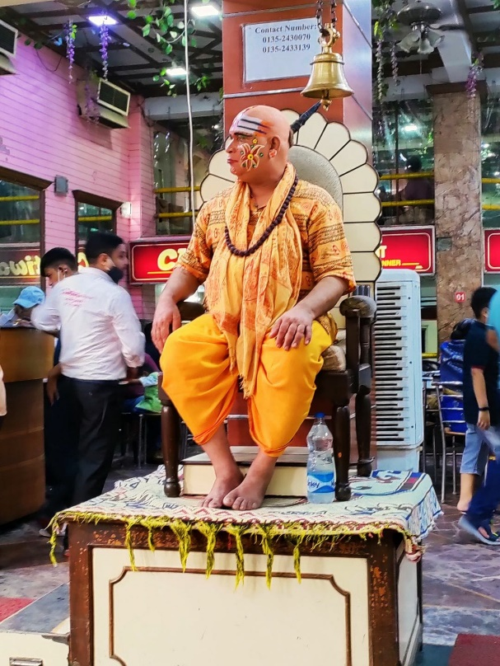

As we had covered ashrams, we were so tired that we knew where we wanted to eat. We headed to Chotiwala, our favourite restaurant. Although it had been 12 years since I ate the food over there, I still remember its taste. The best ending to a thali meal is hot, delicious Gulab Jamuns.

A relaxed, slow-moving vibe, it's spiritual, but not just in the traditional sense. It's just so different from the rest of India to be so heartfelt. In a unique manner, Rishikesh is peaceful and welcoming. In this city, we felt safe as women travellers. Rishikesh is so enchanting and blissful that it makes me want to go there again and again.