The night was as dark as the bottom of a well when I stepped out of the airport in Paris and onto the bustling streets. The city was alive with the sound of chatter and car horns, the bright lights illuminating the frosty air. I bundled up in my warmest coat and scarf, ready for the adventure that awaited me over the next three days.

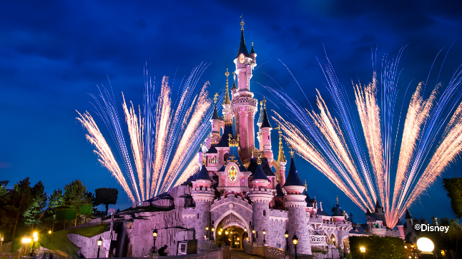Day one was spent at Disney Land, where I felt like a kid again as I rode the roller coasters and met my favorite Disney characters. The excitement and wonder in the eyes of the children around me only added to the magic of the place. I spent hours wandering through the different lands, taking in the sights and sounds of each one. I even got to watch the parade and fireworks display at the end of the day, which was truly a magical experience. However, my day was not without incident, as I was kicked out of a ride while waiting in the line because I had spit out a piece of chewing gum without properly disposing of it. It was a humbling reminder to always be mindful of my actions and the impact they have on my surroundings.

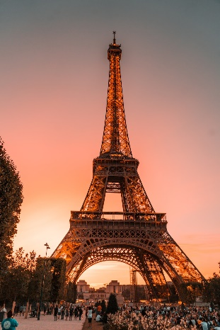Day two was dedicated to exploring the city's monuments. I started off by visiting the Eiffel Tower in the morning, climbing the stairs to the top to take in the breathtaking views of the city below. Next, I visited Notre Dame, marveling at the intricate architecture and history within its walls. I walked along the Seine River, passing by the Louvre and the Arc de Triomphe. Each monument grander and more beautiful than the last. I even had the chance to visit the inside of the Louvre and see some of the famous artworks it houses. Though the monuments were stunning, the streets of Paris had a certain smell that was not so pleasant. The smell of exhaust from cars mixed with the smell of garbage and sewage, which was a bit of a distraction from the beauty of the city. I also used the metro in Paris, which was very different to the one in Switzerland, it was more crowded and chaotic.

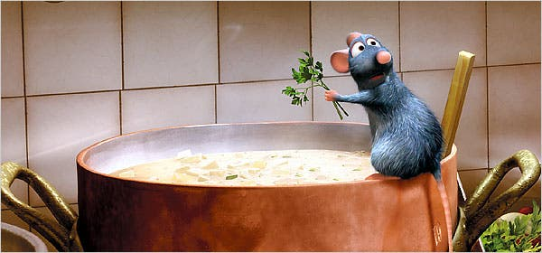 On the last day, I decided to indulge in some of the famous French cuisine. I started the day with a croissant and coffee at a local café, and then I went to a traditional French bistro for lunch. For dinner, I went to a Michelin-starred restaurant where I had an unforgettable meal. After Dinner I went to stand that specialized in African cuisine from francophone countries and the deserts there were truly amazing. The flavors, presentation and service were extraordinary, and it was a fitting way to end my trip.

As the night ended, I couldn't help but feel a sense of awe and appreciation for the city of Paris. The monuments stood as a testament to the rich history and culture of the city, and my DIY cold therapy of wandering the streets in the frosty air only added to the memorable experience. The three days I spent in Paris felt like a dream, and I knew I would always treasure the memories of my trip and the delicious food I had.