**How to create a best friend travel bucket list, overcome FOMO**



Ever felt like your life is boring and dull? Do you feel that your friends are having fun and hope you were in their shoes? This is a feeling of FOMO.

When we see nice pictures that people post on Facebook or other social media platforms, the FOMO fear tends to attack many of us.

Never heard the term FOMO? No problem! Let’s understand FOMO.

**What exactly is FOMO?**

FOMO is the Fear of Missing Out. It became popular with rise of social media. People experience increased stress or anxiety from missing out on social events. They may have not been invited to or not able to attend those events or parties. FOMO has an adverse effect that it limit’s one success. It triggers negative feelings such as loneliness and boredom. Persons who experience FOMO feelings are frequently active on social media. They are constantly exposed to pictures, videos and statuses of other contacts that are actively out doing some activities and having fun.

**Make a travel bucket list with your best friend/friends**

To overcome the feeling of FOMO, you need to do things or activities that interest you most. Do what you like to. It is a good idea to create a best friend travel bucket list and enjoy life. While you enliven your friendship and make the most of it, you’ll notice your fear of FOMO vanishing out.

We are truly blessed when we have a genuine best friend in our life. We enjoyed our school days and college days with them, isn’t it? Then why not make a travel bucket list that includes your best friend or friends too?

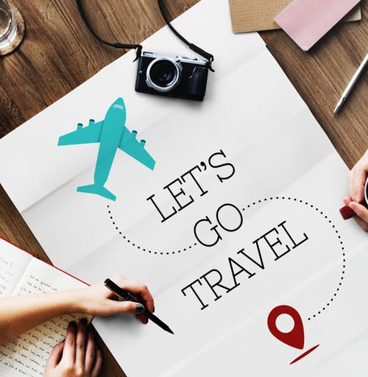

**Here’s how you can create a best friend travel bucket list?**

All you need to do is plan up and pack your bags and go! Our work, relationships and worries are our responsibilities. Agreed! But it is equally necessary to take a break and enjoy your time with your best friend. And why not, we can always count on them, no matter what. But yes, to travel you need to gather inspirations, save money, make a budget and decide on your days for vacation from your work. You may even need to book your tickets if you are traveling somewhere else or globe-trotting.

Wait a minute! You are thinking where can you go? Don’t worry! To give you an idea I have listed a list of many places where you can travel with your bestie and also the fun activities you can do:

1. **Go on a backpacking adventure**

An adventurous backpacking trip lies in the lap of Himalayas in Kathmandu, Nepal where you can visit the most world heritage sites in the world. If you feel you can even travel to the nearest backpacking destinations with your best friends. It’s a trip worth going with amazing experiences to cherish about for lifetime.



1. **Experience a cruise trip**

Wake up to a new city everyday! With your best friends you would really not miss out on all the fun. It is definitely a great experience to take on. Indulge in scrumptious and exotic food in its numerous restaurants, several entertainment options such as gaming zones, movie theaters and partying zones. Treat yourselves to wonderful choices for relaxation such as beauty treatments, rejuvenating spas and relaxing massages. Laze on the deck with your favorite drink and snacks and chat long with your friends. You can travel and visit many cities in your cruise trip and a lot more that is not to be missed.

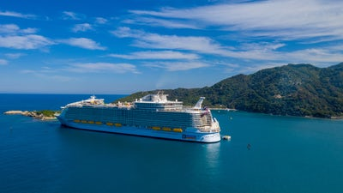

1. **Opt for water activities**

You can visit a beach and head to swim with your besties, smell the ocean air, go on a walk in the sun or play beach volleyball. Relax on a towel and read a book and get tanned in the sun. Another super alternative is to enjoy splashing with adrenaline rides in water parks. Other fun options include sunset sailing, sea kayaking, snorkeling, scuba diving, windsurfing, white water rafting, etc to name a few.

1. **A long drive**

Plan a long drive with taking turns on driving with your best friends. The long road trips increases your friendship bond, builds a deep understanding for each other, inspires deep conversations and build lasting memories. These are little things that you would not imagine to do without your best friends for sure. Guess where will the road take you to?



1. **Whole country tour**

It’s an exciting idea to tour in the whole country with amazing and new experiences. Further, it becomes more interesting when either you or your friends have good knowledge about any state, city or town that you visit. Travel is a lot of fun when done especially with friends. Also, you gain abundant knowledge about the languages locals speak, their culture, food, traditions, etc.

1. **Go around in your city**

There may be many unexplored places to visit in your city. Try to explore them. They can be heritage sites, parks, gardens, music concerts, bands, marathons, stay over at your favorite hotels to unwind with your friends, game zones, bowling, dine at your desired restaurant, the list is endless though.

1. **Climb the mountains**

Mountain climbing feels more enthusiastic when you have best friends to accompany you. You can share each other’s experiences, camping and chill out at night with camp-fire and singing your favorite songs. This superb experience will perk up your lives and give you eternal memories to treasure in your memory bank.

1. **Visit beautiful hill-stations**

All hill-stations are filled with beautiful and breath-taking landscapes that are worth taking photographs. Let the inner photographer in you capture the stunning views and you and your friends can adore these moments and value the time spent with each other. For once you will want to retire and settle in these hilly regions and spend the rest of your life there.

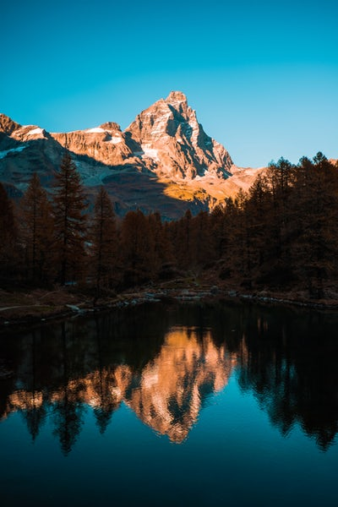

1. **A cycle ride**

How can we forget our childhood days, cycling to each other’s places or going to classes together on a cycle? It was incredible. So when you have an opportunity for a cycle ride with your friends, why wait! Relive your childhood days again and explore your city once again but on a cycle. Cool!



1. **Shop till you drop**

If your allowed to shop and have fun without worrying about spending money and no time limits. This is a fun and interesting thought to turn into reality with your besties. Go shopping to those places where you always wanted to with your friends and do shopping, shopping and more shopping. Flea markets and shopping malls are also great to satiate your shopping sprees.



These were some of the ideas that could help you out to build your own travel bucket list with best friends. I hope the above-mentioned ideas will help you to triumph over your FOMO fear and fill you with more enthusiasm and happiness.

After you enjoy your travel bucket list with friends, you will think and realize that you have risen above the FOMO fear. Also, this will be the best decision of your life! Now think what is more important- you or your FOMO? The choice is upon you.