How I ended up in a police station in China!

The dreadful cold night started with a sumptuous dinner and discussion on all things Chinese with my friend Cathy who also introduced me to village life in China by inviting me to spend few days in her village. (You can check here about my experience in her village and a day spent at her kindergarten.) After the dinner, I was leaving for the hostel but then decided to catch a late night train to visit Great wall of China in morning. Thanks to hardly in use apple map, I ended up in a police station instead of the hostel near great wall of China where I was planning to spend the night 😐



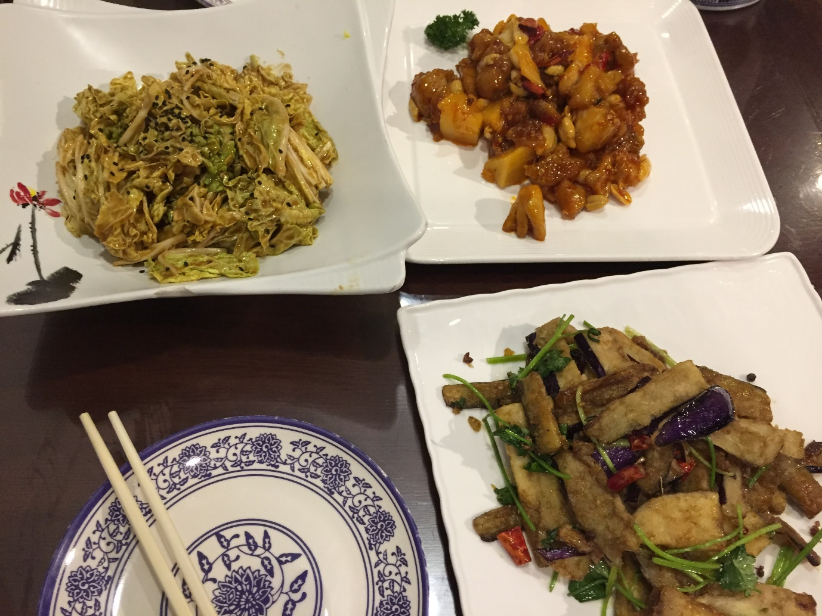

So in China all (except one) the google applications such as google map, gmail are blocked, thankfully though they have not blocked Google Translate which comes very handy while interacting with local people since majority of people in china don’t speak English. Apple map sucks big way, not only because of poor navigation interface but also it has dated and wrong information in many instances. Apple map showed that there is a train to catch from a station on the outskirt of Beijing. But when I reached there by a connecting train ( which was unfortunately the Chinese equivalent of “*ek chalis ki last local*”) I found that there is no train and on top of that station was closed. Yeah right, some station get closed in night in China. The whole area around the station was deserted like this ☹

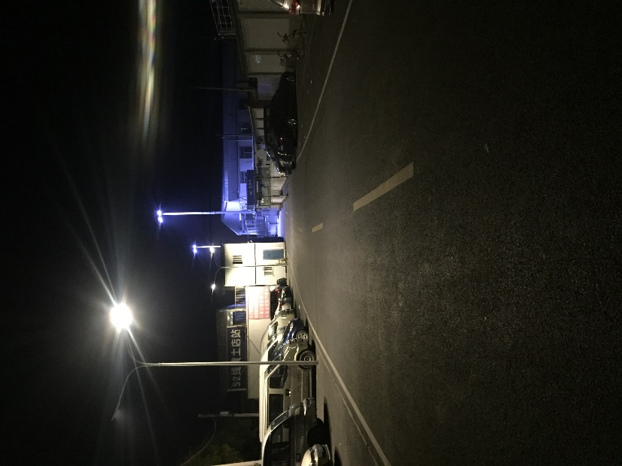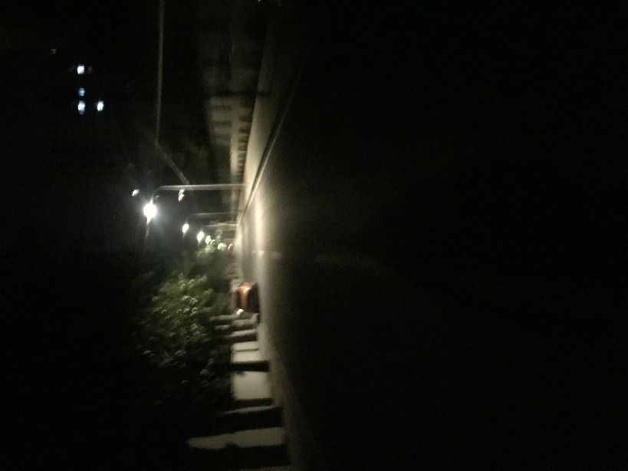

Thanks to my previous good experience in China, I was confident to an extent that probably I will not get bugged , finger crossed though. After walking for around 1-2 km with few stones in hand for rare stray dogs in China, I found one young Chinese couple who were cycling. Cycling is one of the best and super economical (check here how I rode for a month in China using bicycle, that two for free!) mode to commute in Chinese cities. I told them about my situation and asked them for help using Google Translate. Love you Sergey & Larry.. RIP Steve and Apple Map

The couple took me to a nearby B&B, but the uncomfortable cold night was not over yet! Though instead of getting anxious, I was now mostly getting amused 😊 The hotel manager ( he was just like a typical caretaker that you see in any budget hotels in India.. He wanted to go back to his sleep and us to get lost. I didn’t knew that many small hotels in China require local Chinese id card to check in. So he denied me a room. The couple was also getting worried and they suggested we should call local police station and they can help me! Now I guess, I was getting a little nervous. Mention of police, reminded me of my encounter with Indian police in UP in Mathura. I guess before asking me anything first they will abuse for spoiling their nap… I thought the Chinese police will also be more or like Indian police and I should be getting worried now.. but I was in for a pleasant surprise. The two policemen came in their well-maintained vehicle as they show in Hollywood movies. One of them started a video device placed on his chest and started inquiring about my passport, hotel bookings, destination etc. Google translate was acting as a mediator between me and the couple and the couple were acting as a mediator between google translate an police, because they were more comfortable talking in Chinese rather than typing on google translate. He also asked the hotel manager to give me a room, but he refused again citing local law. They asked me to come with them, I was afraid they should not take me to a costly hotel I left with them after exchanging number with the couple who were so kind, helpful and patience during this whole time. Thankfully the police took me to a police station instead of a hotel C:\Users\Neetesh\AppData\Local\Packages\Microsoft.Office.Desktop_8wekyb3d8bbwe\AC\INetCache\Content.MSO\5E514F9F.tmp

The senior cop (he was not smiling so I guess he must be senior) signalled towards a couch and asked me to spent the night there. The junior cop was more jovial though , after taking few selfies he offered me a tea, and finally after a long night I got a much needed sleep. I guess

