# **An Indonesia that is not Bali: Hiking volcanoes in Indonesia**

Bali and Indonesia have become so synonymous that people think Bali=Indonesia. For the readers information, Indonesia has 17,508 islands, making it the world's largest archipelagic state and exploring them all would need a fortune of money and probably a considerable part of our life would be spent in doing so. Indonesia, however, is one of the most diverse countries when it comes to getting mesmerized by nature. It has everything, from blue waters to volcanoes, waterfalls and forests. Itoffers amazing options for snorkeling, scuba diving, hiking and other adventures.

We started searching on internet about each and every island of Indonesia and shortlisted Belitung and Java. Belitung for a beach holiday and Java for volcano hike because hiking a volcano is a onetime experience and when Asia gives this option, why go far?

So here is my itinerary and experience of hiking Indonesian Volcanoes

**Mount Bromo:** This volcano is active and is popular for its breathtaking sight of sunrise. One can reach Bromo from Malang or Surbaya. We chose Surbaya as our pickup point. The tour guide picked us up and we reached Probolinggo by road. On the way to Probolinggo, we visited Madakaripura waterfalls which is an amazing waterfall with a scenic trail.

Madakaripura Waterfall

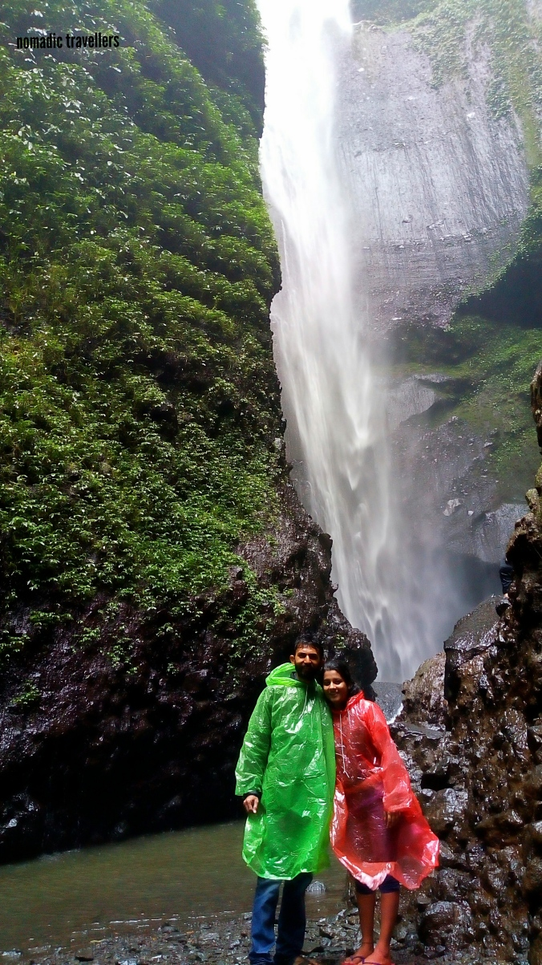

We reached our hotel in Probolinggo, relaxed for a while, had dinner and started our journey towards the East Javan Volcano. It’s a bumpy jeep ride from the base to the volcano. It was cold and windy but what we saw next was worth the wait. An unforgettable view of sunrise, clouds sliding apart, giving us more and more beautiful view.

Later we climbed up the mountain to reach the crater. It was the first time we saw an active volcano. What an experince!

**Sunrise at Mount Bromo**

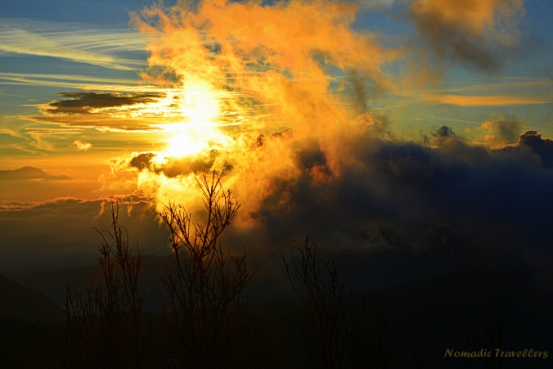

That’s us… Taking filmy shots :p

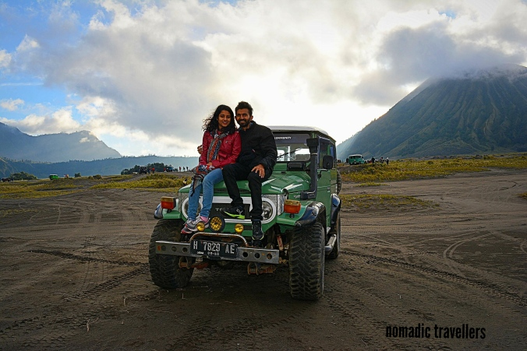

Mount Ijen : This volcano is one of its kind in the East Javan region. It deserves to be visited by travellers. The turquoise blue lake at the crater is the acidic lake, thanks to the sulphur content in the lake. This lake, according to the locals, is the largest acidic lake in the world.

The acid lake

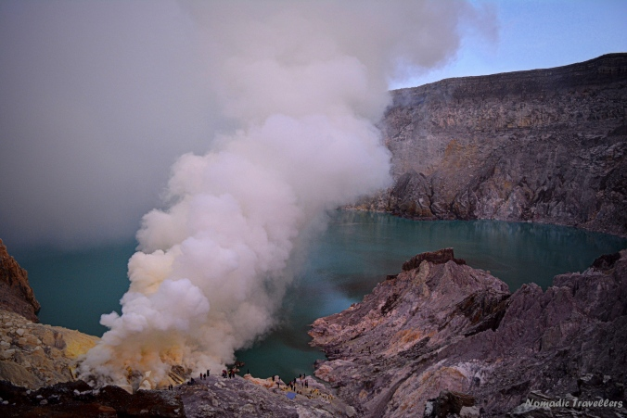

Apart from that, one can see the blue fire, a rare sight in this world. The sulphur fumes emit blue coloured fire at the crater making it a wonderful attraction for travellers.

The blue fire

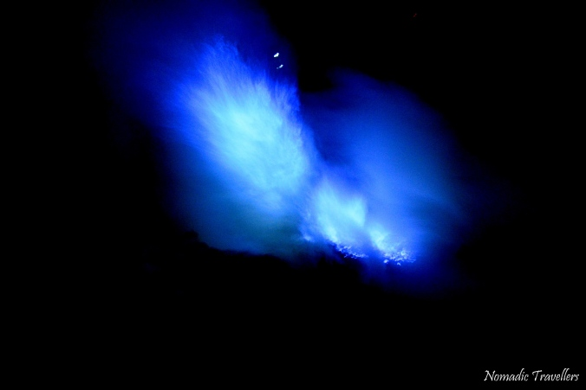

Sulphur mining is the main occupation of the people in this area. During the visit, I realized how difficult it is for some people to earn for their living.

If you want to see the blue fire, take a night trek. It’s a long walk, it would be cold but the experience and the sight at the site would make it worth every step you climbed.

For both the volcanoes, I would recommend taking a local guided tour since it is not easy to get public transport and reach everywhere on time to see the breathtaking sights.

We had an amazing experience with  
[https://instagram.com/megatravel.id?utm_source=ig_profile_share&amp;igshid=e113uxg6iu86](https://instagram.com/megatravel.id?utm_source=ig_profile_share&igshid=e113uxg6iu86)

We hope this blog encourages more and more travel enthusiasts to travel to the “less famous” yet equally beautiful regions of Indonesia and get mesmerized by its breathtaking beauty.

Regards and Love

Sanika and Aditya

Happy Travelling!!!!!

*One's destination is never a place but rather a new way of looking at things" (Henry Miller)*