**Brotherhood on Wheels: Dubai Biker Gang’s Trip to Spiti***Story of Dubai-based Glorious Bakchodars’ trip from mundane-ness to mountains*

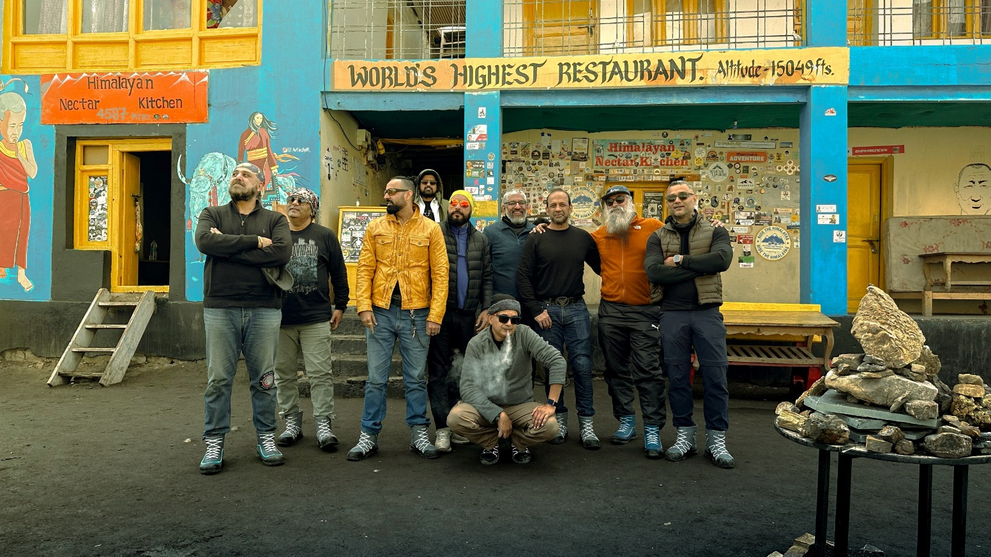

**“***How was Spiti?”*

*“After this ride, everything else seems easy,” Charanjeet says with a chuckle.*

The Glorious Bakchodars, a gang of adventure-loving misfits from Dubai, recently embarked on a daring journey through the rugged landscapes of Spiti. Navigating through landslides and boulders ten times their size, they still wonder how they made it back home in one piece.

Known for cruising the cosmopolitan streets of Dubai in their Harley Davidsons, the gang of members aged between late 30’s to 70’s knew they had to take their passion to newer roads.

Riding up to new heights—quite literally, they swapped the city’s asphalt for the dusty, unforgiving paths of the Himalayas. Armed with Royal Enfields, they rode India’s most treacherous terrain with the motto *“Screw it, let’s ride.”*

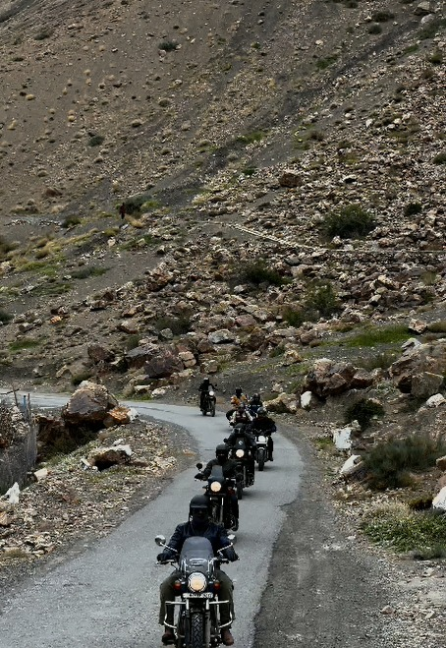

**“Made Like a Gun, Goes Like a Bullet”**

Unlike today’s sleek, tech-packed motorcycles, Royal Enfields were made for the sole purpose – goes like a Bullet. Be it through unpaved roads or unpredictable weather, Enfields were created to challenge the unknown.

A legacy icon on the mountain roads, Royal Enfield mirrors the gang itself—rebellious and unyielding. So, even though Spiti was a demanding ride, the Bakchodars picked the right bike to face the adversities.

Forging a deeper connection with these man-made machines, the gang developed a whole new respect for the Indian bike and terrains after the Spiti circuit.

**Brotherhood on Wheels, Fuelled by Rum**

Night rides with near-zero visibility might sound horrifying to many, but it was a test of trust and camaraderie for the biker gang.

At moments like these, one couldn’t help but remember our mother’s saying: *“If your friend jumps off a building, would you too?*” In this case, the Bakchodars did just that, following each other into the unknown, purely guided by their instincts and headlights.

To make the ride smoother, the gang brought along their unofficial member: bottles of Wise Monkey Rum. Owned by one of the members of the group, Jagdeep Singh, the award-winning Rum compliments their love for all things bold and authentic.

Another Bakchodar, Manjeet Singh, recollects how they’d pop open a bottle to celebrate every milestone - be it under the starry skies at Chandra Taal Lake or after conquering yet another dangerous water pass.  With each toast, they celebrated survival, brotherhood, and the unforgettable moments the ride brought them.

Finding a laugh around every corner, they’re known to embrace life’s unpredictability with their Bakchodi (goofy bullshitting). So, the absurdities that Spiti presented to them, even though unexpected, became an extension of their gang’s motto.

**Next Stop: South Africa**

Even when Spiti threw sticks and stones at them, the bikers gloriously sped through the trails. With snow-capped peaks towering like ancient sentinels, they offered their honors to the temple of adventurers by leaving behind dust clouds with every spin of their tires.

Now, with the Spiti circuit under their belts, the Glorious Bakchodars are setting their eyes on their next destination: South Africa. No longer strangers to tough terrains, there’s absolutely no telling how far their Bakchodi would take them along.

There are no limits – just more roads to explore and wild ideas to chase. Like the gang’s member, Sultan said, *“If it has wheels, will ride it.”*

