# Top Three Magnificent Heritage Hotels in India Yet To Be Discovered

After the advent of commercialisation, several palaces, forts, havelis of erstwhile princely states were given a heritage look and converted to heritage hotels. With time, these hotels received accolades for their grandeur and splendour for providing royal and luxury services to their guests. Although there have been various famous heritage sites in the top list among various hotels, yet there are many other hotels which are not much popular but as superb as their popular counterparts. Here we are presenting such unheard heritage hotels which have been maintained in good shape and provide excellent hospitality services to their visitors.

# Samode Palace

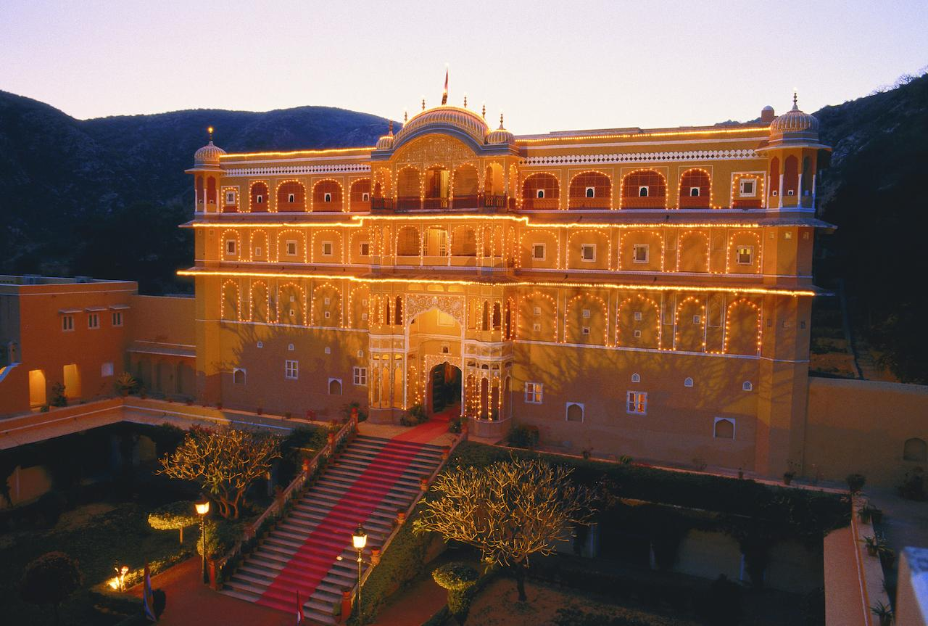

**Situated at**: near Jaipur, Rajasthan

**Rating:** 4-Star Hotel

**Build in**: In the 16th Century

**Famous for**: Indo-Saracenic Architecture with a combination of Indian and Mughal styles. Situated amidst Aravalli Ranges and built of sandstone, it is well kept with wall paintings and antiques occupying every corner of the hotel. Once the residence of the royal family, it has now been converted into a heritage hotel and acts as a “soul rejuvenator” for the visitors. Visit this place to explore the magic associated with the hotel and a rare courtesy offered by it.

**Rooms and Services**: It has 43 rooms, out of which 20 are Deluxe Rooms, 19 Deluxe Suites and 4 Royal Suites all of which are decorated as per the Rajasthani style with all modern amenities. The in-house restaurant offers a mix of Asian and European cuisine. There is also the availability of some unusual services such as snacks by the pool and a-la-carte in the courtyard. Yoga classes and Ayurveda spa centre are also available.

Nearby Attraction: Lakkar Haveli, Jantar Mantar, Hawa Mahal, Samode Bagh and Haveli

**Price Range**:

Deluxe Room: Rs.9300

Deluxe Suite: Rs.12400

Royal Suite: Rs.25000

# Netuk House Hotel

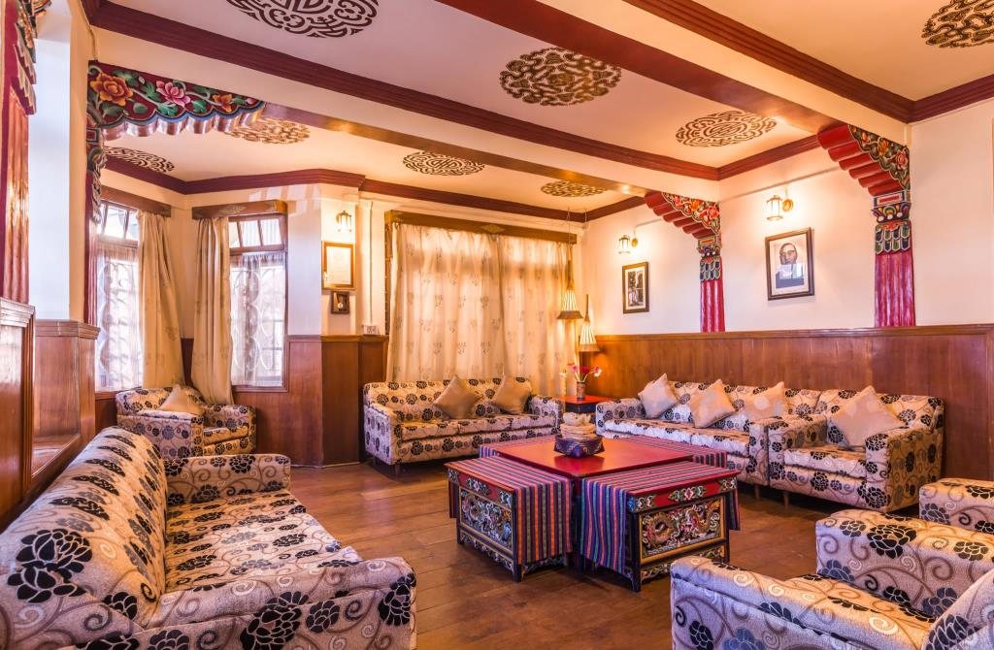

**Situated in**: Gangtok, Sikkim

**Rating**: 3-Star Hotel

**Built in**: 15th Century

**Famous for**: Resident of Gellong Netuk Lama, the executive councillor of the Chogyals of Sikkim. As it is situated along the ancient Silk Route, it has been associated with traders historically which reflect in its architectural design. It offers beautiful scenery of the town with a view of Khanchendzonga which is no less than heaven for lovers of nature.

**Rooms and Services**: It has 10 rooms which are tastefully designed with all modern amenities for comfortable stay of the guests. The in-house restaurant offers multi-cuisine Sikkimese dishes which are mouthwatering and delicious.

**Nearby Attraction**: Ranka Monastery, Yumthang Valley

**Price Range**: Rs.5000/day

# Chapslee Heritage Hotel

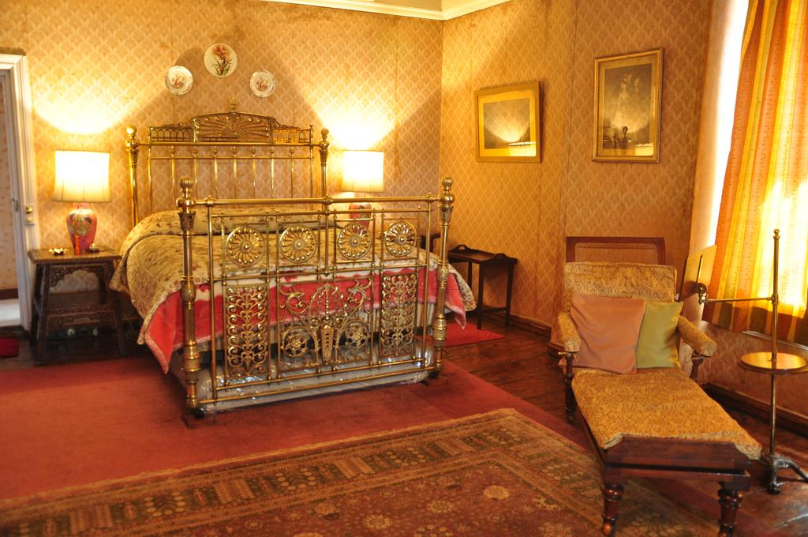

**Situated in**: Shimla, Himachal Pradesh

**Built in**: 1828-1835

**Famous for**: Summer Residence of erstwhile Maharaja of Kapurthala and one of the first heritage hotels in India. Noted for multi-blended architecture; interior is decorated with baroque furniture and with Afghani carpets, Mughal ceramics and Gobelin tapestries further add grandeur to the hotel. Opened for the public in 1976 and is known for picturesque location and warm hospitality. Only vehicles with a special permit are allowed to travel the road leading to the hotel.

**Rooms and Services**: Rooms are available under three categories namely; Luxury Suite, Deluxe Suite and Standard Suite. The hotel has a tennis court, card room, croquet lawn, and a library that has a collection of books on travel and architecture. The in-house restaurant serves traditional Punjabi and Himachali cuisine which would make awe of the place by the guests.

**Nearby Attraction**: Himachal State Museum, Mohan Shakti Heritage Park, Kali Bari Temple, Christ Church

**Price Range**: Rs.23000- Rs.30000