**Keyword:** car hire for outstation

**SEO Title:** Key points to keep in mind when hiring a car for outstation travel

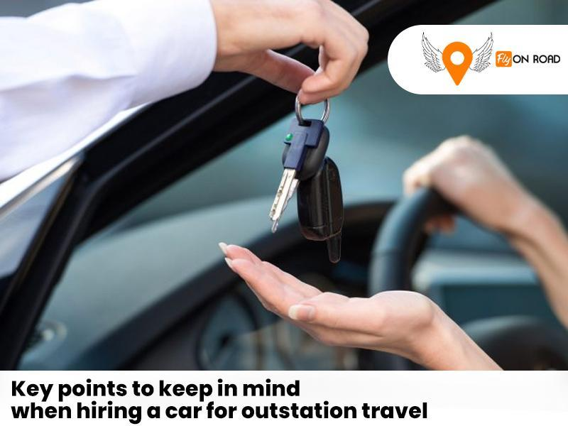

Are you going on a weekend getaway or a short trip? Here are five crucial factors to remember when **hiring a car for outstation travel**.

* **Choose the Right Car for Your Group:** A comfortable journey is paramount to an enjoyable road trip. Select the appropriate car size based on the number of people in your group. Fly On Road offers a wide variety of cars to cater to your needs when booking a car for an outstation road trip.
* **Check for One-Way Trip Options:** Fly On Road offers the flexibility of being dropped off at your destination without charging you the return fare for the one way trip.
* **Excellent Customer Service:** A responsive and reliable customer service team is indispensable, especially during a road trip. Select a car rental like Fly On Road, which provides round-the-clock assistance for all your queries.

Make your road trip stress-free by choosing the exemplary car rental service. For a seamless experience, consider Fly On Road, a trusted name in **car hire for outstation travel**.

https://g.co/kgs/X2uy7o