# Dubai Travel Tips: Exploring the City's Landmarks

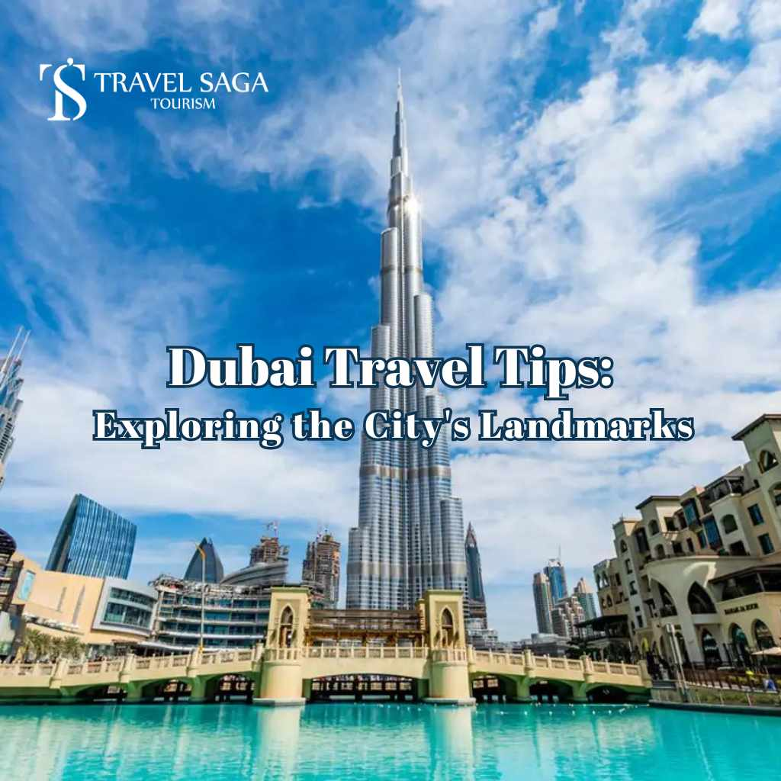

Dubai is a city which has something for everyone. I have had the pleasure of visiting the city with the best tour operator in Dubai, Travel Saga. Here I am sharing my trip experience and some travelling trips for everyone who wishes to explore the dynamic city of Dubai. From Dubai desert safari, Burj Khalifa, theme parks to water parks, and so much more. Let’s learn about some must-visit [Dubai tourist places](https://travelsaga.com/dubai-tourist-places/) and tips to enhance your travel experience.

## **1. Burj Khalifa: From Heights to Highlights**

When we think of Dubai the first thing that pops up into our mind is indeed the Burj Khalifa so that is the first stop of our journey. With an elevation of 828 metres, the 148th-floor observation deck provides stunning city views. I advise purchasing your tickets ahead of time to avoid standing in queue. To see the sunset, early in the morning or late in the afternoon is indeed the ideal time for you to visit. Lastly, remember to pack your best camera lenses because the views from At the Top will blow your mind.

## **2. The Dubai Mall: Shop til you drop**

One of the biggest retail centres in the world, The Dubai Mall, is located just beneath the Burj Khalifa. There are many things to do here even if shopping isn't your cup of tea. The Dubai Mall has an indoor theme park, a large aquarium, and an indoor ice rink. Furthermore, seeing the Dubai Fountain, which is held outside the mall in the evenings, was one of my greatest experiences in Dubai. The music, light, and water performance is really captivating. There is also an Abra boat ride experience which you can try.

## **3. The Palm Jumeirah: The beautiful human made island**

Surrounded by immaculate beaches and opulent hotels, this artificial island known as The Palm Jumeirah is fashioned like a palm tree. This is certainly one of the best places to visit in Dubai. I spent a day at the aquarium and an amazing water park at the Atlantis, The Palm. Try one of the numerous excellent dining establishments like Ossiano, a 1 Michelin star fine dining restaurant on the island. Take a monorail trip through the Palm to see the island up close for breathtaking vistas.

## **4. The Desert Safari: Golden Sand, Golden Memories**

A [desert safari in Dubai](https://travelsaga.com/desert-safari/) is an essential part of any trip. Among the best parts of my vacation was this. I chose the overnight desert safari option, which included camel riding, dune bashing, and a typical Bedouin tent experience complete with entertainment such as Belly dancing and a fire show with a luxury BBQ dinner. A look at the classic Arabic way of life is provided by the entire experience, which includes a breathtaking sunset over the desert.

## **5. Water Sports: Let’s get wet!**

The one thing which you cannot miss when you visit Dubai is trying out the numerous water sports. I reserved one whole day just to try numerous water sports at Dubai Marina. The most fascinating water sport was the Jet Car, it can be manoeuvred just as smoothly as any other car and you can also stop it occasionally to interact with other tourists or locals and look at Dubai tourist attractions. These cars are very comfortable and a ride through Dubai’s waters can be very relaxing indeed.

### **Travel Tips for Dubai**

* Drink plenty of water since Dubai can get quite hot, especially in the summer. Keep a bottle of water on you at all times.
* Although Dubai is more liberal than other Middle Eastern cities, it's still vital to honour local traditions by wearing modest clothing, particularly when you're in public.
* The tram and metro systems in Dubai are economical and effective. Additionally, taxis are reasonably priced and extensively accessible.
* Recognise the traditions and practices of the area. Public demonstrations of affection are discouraged, and it's essential to observe the customs and dress code of the community.

## **Final Words**

Dubai never ceases to astound with its seamless fusion of cutting-edge modern technology and ancient customs. There is no lack of things to do and see, whether you're scaling new heights at the Burj Khalifa, living it up on the Palm Jumeirah, or enjoying the exhilaration of a desert safari. Following these suggestions, you'll be ready to explore and take advantage of everything Dubai offers. Lastly, contact the best tour operator in Dubai, Travel Saga to customise your tour packages.