**RESUME**

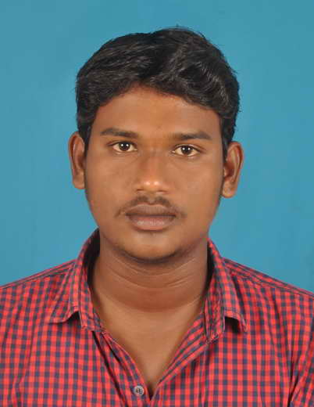

**PRAKASH.S**

No: 59,4TH MAIN ROAD, 3RD CROSS STREET,

VASANTHAPURI, PERUMALERI,

MAMALLAPURAM – 603104.

**Email: karthick7004@gmail.com**

**Phone. no: +91 9003063398**

**OBJECTIVE**

Seeking a challenging and rewarding career in an organization where I can make significant contribution toward achievement of organization goals and realization of my own potential by focused application of the knowledge and skills that I have acquired.

**ACADEMIC QUALIFICATION:**

|  |  |  |  |  |
| --- | --- | --- | --- | --- |
| **Course** | **Institution** | **Year of completion** | **Board/University** | **% marks obtained** |
| **B.E. (ECE)** | ROYAL COLLAGE OF ENGG & TECH | 2014 | Anna University | 67 % |
| XII | GOVT. HR SEC SCHOOL | 2010 | Tamil Nadu State Board | 73 % |
| **X** | St’ JOSEPH’S HR SCHOOL | 2008 | Tamil Nadu State Board | 81.4 % |

**Experience:**

* **Wo**rking 2 year in HEBRON TRANSPORT at Chennai.
* Company  **:** HEBRON TRANSPORT
* Destination **:** Booking & Marketing Executive, Dispatching report
* Role : Agent Support
* Experienc**e :** 2 year**s**
* **Wo**rking 2 year in PRAKASH TOURS & TRAVELS at Mamallapuram.
* Company  **:** PRAKASH TOURS & TRAVELS
* Destination **:** Admin Executive,
* Role : Admin & Agent Support
* Experienc**e :** 2 years
* **Wo**rking 3 year in YBM TRAVELS at Chennai.
* Company  **:** YBM TRAVELS PVT,LTD.
* Destination **:** Branch Manager,
* Role : Admin & Maintainence
* Experienc**e :** 3 years 6 months

**TECHNICAL SKILLS:**

**Software skills** : M.S. Office, C,C++, ( DCA), & Bitla, Vahana, bus software handling.

**Operating system** : Windows XP, Vista, Windows 7, 8,10

**FIELDS OF :**

Work at international and domestic tour operator, Transport operator, booking handling, Maintainence, Booking executive, Bus operations control,online support, Customer support.

**PERSONAL SKILLS:**

* Positive minded
* Hard worker
* Quick learning

**PERSONAL DETAILS:**

**Name :** Prakash.S

**Father name**  : Mr. S.Shanmugam

**Date of birth** : 12.04.1993

**Gender**  : Male

**Nationality** : Indian

**Marital status**  : Single

**Languages known** : Tamil, English,

**Hobbies** : Playing & watching cricket

**DECLARATION**

I hereby declare that all the above information is true to the best of my knowledge and belief.

Yours sincerely,

**PRAKASH.S**

Place :

Date :